ELL302 - Power Electronics

# Intro to Power electronics (not for syllabus, just an intro for exploration)

* 1. A subject dealing with processing of electrical power using electronic devices. Interdisciplinary subject in electrical engineering covering electronics, power and control.

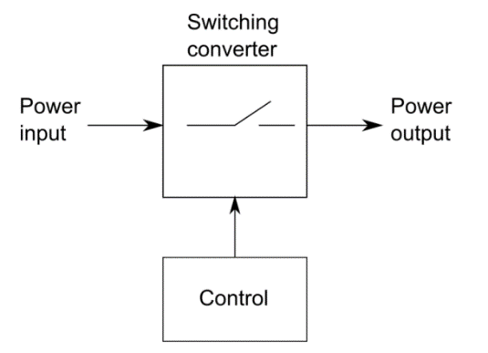

* 1. Encompasses three technologies: Power semiconductor, power conversion and power control

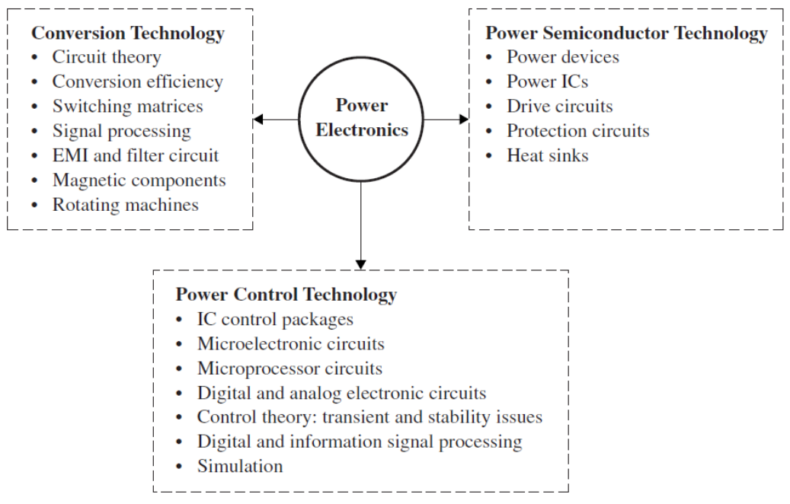

* 1. Motivation to study:
     1. Energy market changing throughout the world, more so in India
     2. Energy conversion now mandatorily controlled by high power electronics
     3. Lot of prospects now and in near future
  2. Application:
     1. Motor drives including electric vehicles
     2. Renewable energy integration (Solar, wind etc.)
     3. Power supplies (e.g., Chargers for EV, Uninterruptable power supplies)
     4. Energy efficiency improvement (e.g., heating/cooling, LED lighting)
     5. Utility applications (e.g., power factor correctors) AND MANY MORE
     6. Eg. EV battery charger: Charging happens from grid to AC-DC rectifier, AC motors controlled through DC-AC converter.

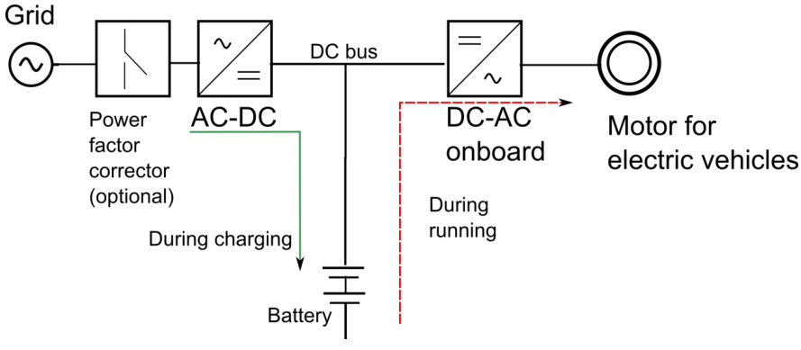

* + 1. Eg. Motor Drives: Motors consume about 50% of total energy of the world, and power electronics is quite vital for motor drive control. Variable speed drives are required in many applications for better efficiency and control over speed of the motor.

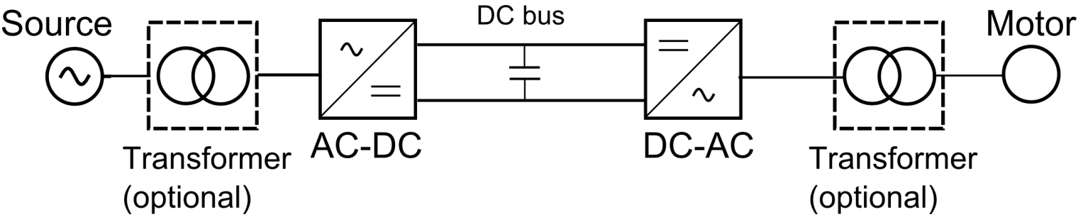

* + 1. Eg. Solar PV system:

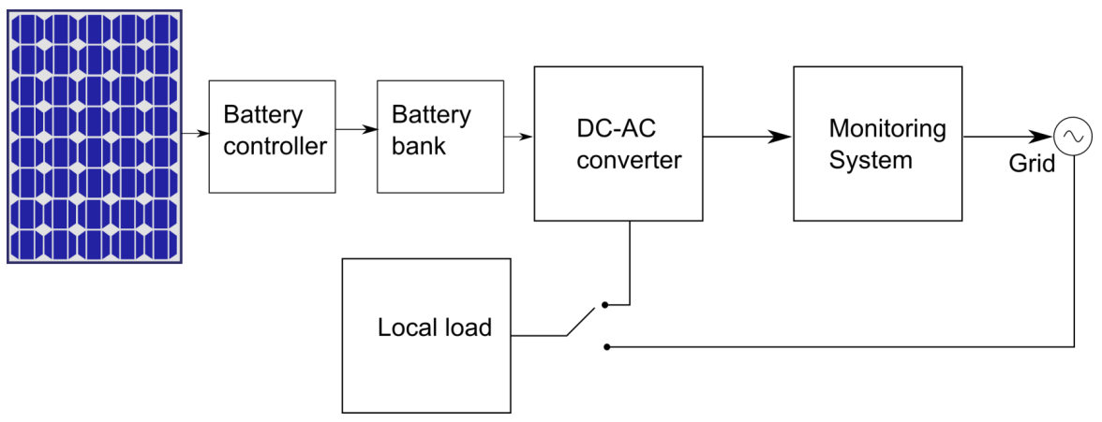

* + 1. Maximum Power Point Tracking for Solar PV system:
       1. When the radiation (W/m2 ) changes, the I-V characteristics changes. (I: current drawn from the PV panel, V: voltage across the panel)
       2. Consequently, the power obtainable from the solar panel changes. It has a maximum point.
       3. In order to extract maximum power from the PV all the time, the I-V characteristics of the PV panel should be varied dynamically depending on the solar insolation and temperature.
       4. This dynamic variation is done through a power converter.
       5. This is called maximum power point tracking of a solar PV panel.

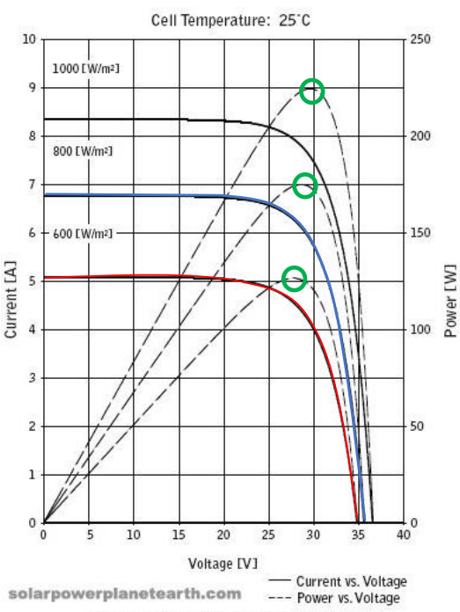

* + 1. Eg. Power Factor Correctors:
       1. 7
       2. To make the source supply current at unity power factor, a compensator is used.
       3. The compensator supplies the reactive part of the load current.

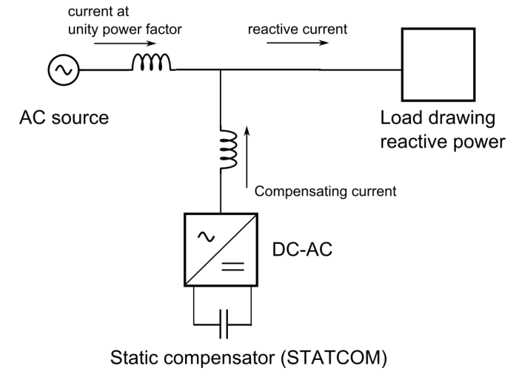

* + 1. Eg. Power Supplies: Incoming grid supply converted to DC, and then a DC-DC convertor used to convert to different values of DC.

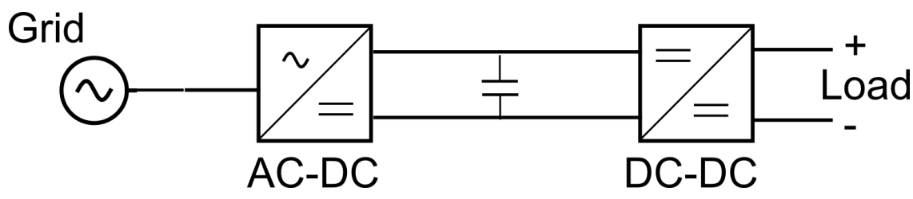

# Conversion Circuit Types and Quadrants of operation

* 1. Types of conversion:

|  |  |
| --- | --- |
| AC-DC (rectifier):  Fixed AC to Variable DC | DC-AC (inverter):  Fixed DC to variable AC |
| DC-DC:  Fixed DC to variable DC | AC-AC (cycloconverter):  Fixed AC to variable AC  (Now obsolete, being replaced by 2-stage process i.e AC-DC then DC-AC) |

* 1. Quadrant of operation:

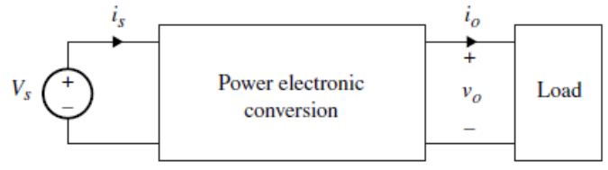

|  |  |
| --- | --- |
| Quadrant 2  Load delivers power to source, work done by load on source | Quadrant 1  Load dissipates power from source, work done by source on load |
| Quadrant 3  Load dissipates power from source, work done by source on load | Quadrant 4  Load delivers power to source, work done by load on source |

# Power Switches

* 1. Different types of power switches and efficiency comparison for a situation (24V source, 12V output to a 6Ω resistor):
     1. Voltage divider: the simple resistance voltage dividing logic

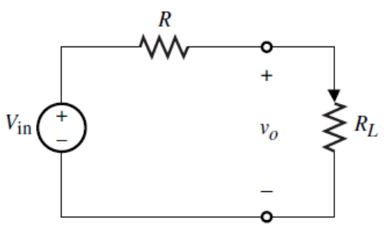

If RL = 6Ω, then R has to be 6Ω. Therefore, the current through circuit is 2A. Voltage across both resistors is 6V (desired), power dissipated across both resistors is 24W. Therefore, 50% loss of power.

* + 1. Linear Regulator: Using MOSFET and gate voltage controller.

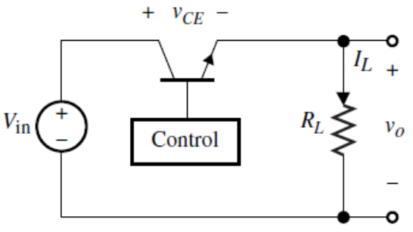

In this case, the voltage across the resistance can be made as 12V by setting vCE as 12V. Current flowing would be 2A. Power delivered to load resistance and power dissipated across MOSFET are both 24W, again, 50% power wasted.

* + 1. Switching Circuit:

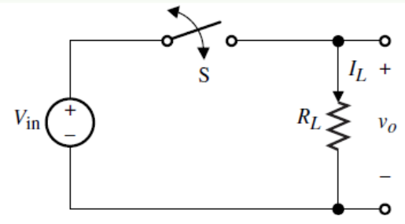

In this case, the switch can be turned on and off periodically, with duty cycle fraction D. Over a long period of time, the average voltage across the resistor becomes 24(1-D). D can be set as 0.5, to make v0 average value as 12V.

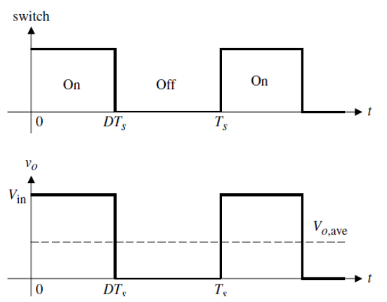

However, the transitions need to be smooth, which can be done by putting capacitors and inductors at appropriate places.

* 1. Need for power switches:
     1. Control energy/power flow from source to load and vice versa.
     2. Increase efficiency, avoiding unnecessary resistance, power losses (which reduce lifetime as well due to heating).
  2. An ideal power switch can block infinite voltage and allow zero current when OFF, allow infinite current with zero voltage drop when ON, has zero switch on and switch off timings, and doesn’t lose performance due to heat. It can also tolerate infinite heat and power losses.
  3. Practical power switches include MOSFETS, IGBT, IGCT, GTO, thyristors (semi controlled), diodes (uncontrolled).

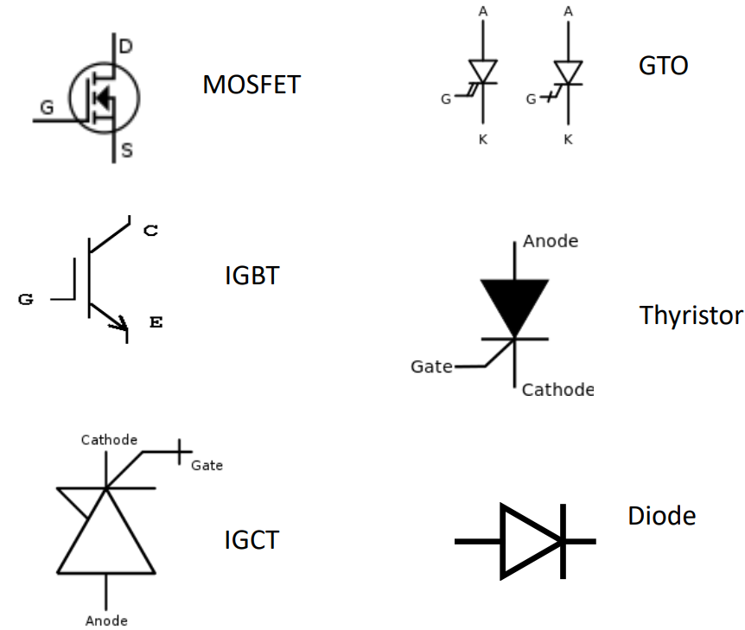

* 1. Practical Power Switches:
     1. Forward voltage drop: Voltage drop across switch in ON state.
     2. Leakage current: Current through switch in OFF state.
     3. Blocking voltage: Voltage across switch in OFF state.
     4. Power dissipated across the switch is finite during conduction and blockage
     5. Switch takes time to turn on/off, and requires energy to turn on/off, provided by gate driver circuits.
     6. A switch can’t tolerate an excessively high temperature and its performance is affected by heating.

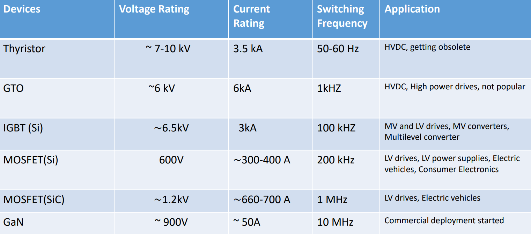

* 1. When passive components are introduced, the voltage drop across them fluctuates continuously in every cycle. This effect can be minimised by putting a capacitor in parallel with the resistance, the V-t graph is shown to the right in blue dotted lines.

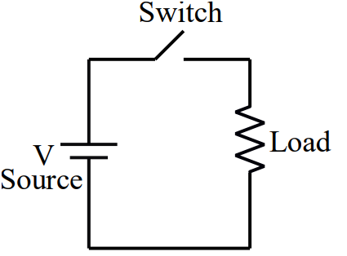 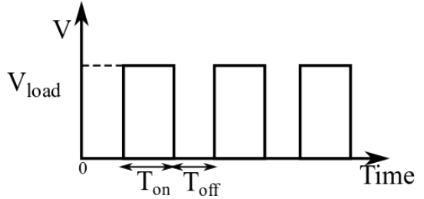 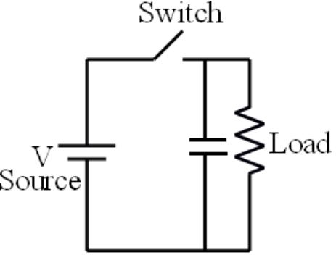 

* 1. The ripple effect of the capacitor can be minimized by adding an inductor in between as shown:

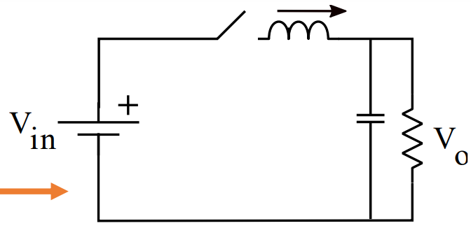

* 1. Dual Switch: eg. The circuit shown below can’t have both the switches closed together, else the voltage source would be shorted.

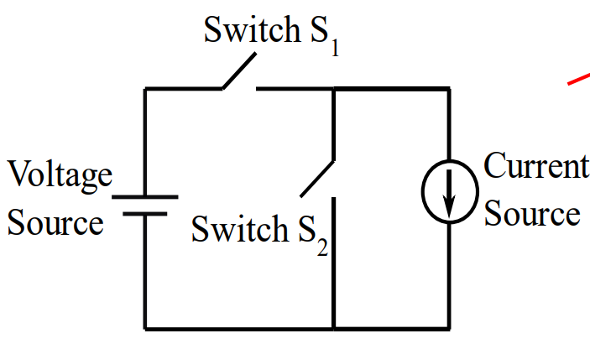

* 1. Switch realization: there are many ways to realize the 2 switches. Eg. IGBT/MOSFET with a diode.

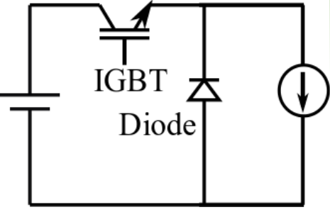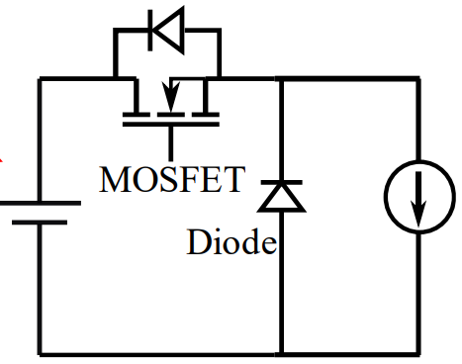

* 1. Voltage rating: voltage blocked by switch when it is OFF. Current rating: current flowing through the switch in ON state.
  2. Quadrants of operation of power switches: I is current during conduction and V is blocking voltage. For instance, a diode can block voltage in backward (-ve) direction and conduct current in forward (+ve) direction. So, it has only 2nd quadrant operation.

# Power Diode

* 1. 2 terminal switch, made of a p-n junction.
  2. ON and OFF state can’t be controlled externally, can be controlled only through the voltage across it by the virtue of the external circuit.
  3. It turns ON when forward biased and OFF when reverse biased.

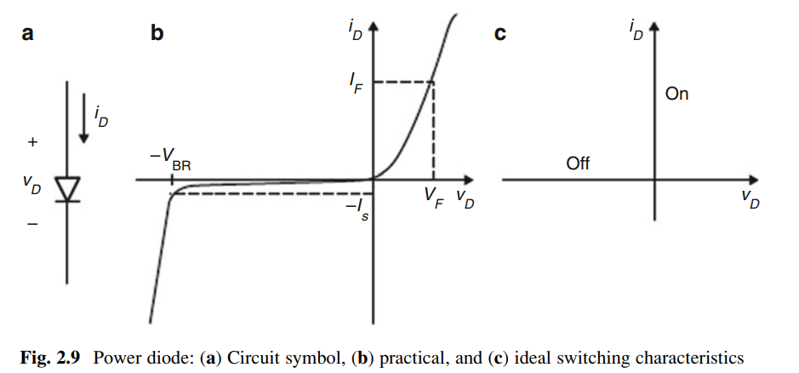

* 1. Two important features of diodes:
     1. Power handling capabilities: power losses, conduction current and blocking voltage.
     2. Forward recovery time (tfr): delay time while turning ON the diode.
     3. Reverse recovery time (trr): delay time while turning OFF the diode (quite large compared to tfr).
  2. There are 2 types of power diodes:
     1. Bipolar diode:
        1. based on p-n semiconductor junction.
        2. Typical voltage drop is <1.5V, and reverse blocking voltage is usually 3kV, with forward current 3kA.
        3. trr is usually quite small, of the order of 50 µs.
     2. Schottky Diode:
        1. Based on metal-semiconductor junction.
        2. Forward drop voltage is nearly 0.5V.
        3. No trr, as current is due to majority carriers.
        4. Large leakage current, so mainly used in high current, low voltage DC power supplies.
  3. Losses in the power diode:
     1. In the on-state diode has a conduction loss (VF * Ion).
     2. Off state conduction losses are negligible.
     3. Turn on loss is also negligible.
     4. Turn off loss is significant.

# Power MOSFET

* 1. Unipolar device, as only majority carriers are used for conduction. N-channel enhancement type power MOSFETs are used.
  2. Fastest power switching device, with switching frequency more than 1 MHz, voltage power ratings up to 600 V and current rating as high as 40 A.

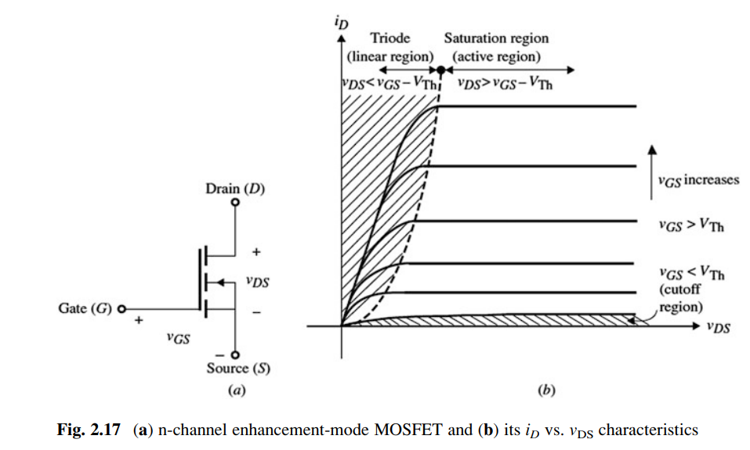

* 1. Power MOSFETs use a vertical channel structure to increase the device’s power rating, where the source and drain are on opposite sides of the silicon wafer.
  2. Because of body diode, the device conducts negative current. Additional anti-parallel diode is also provided.
  3. Used in few kW power range e.g., in dc-dc converters.
  4. Quadrants of operation: 2 (Q1 and Q4). Can block +ve voltage but allow current in both directions.

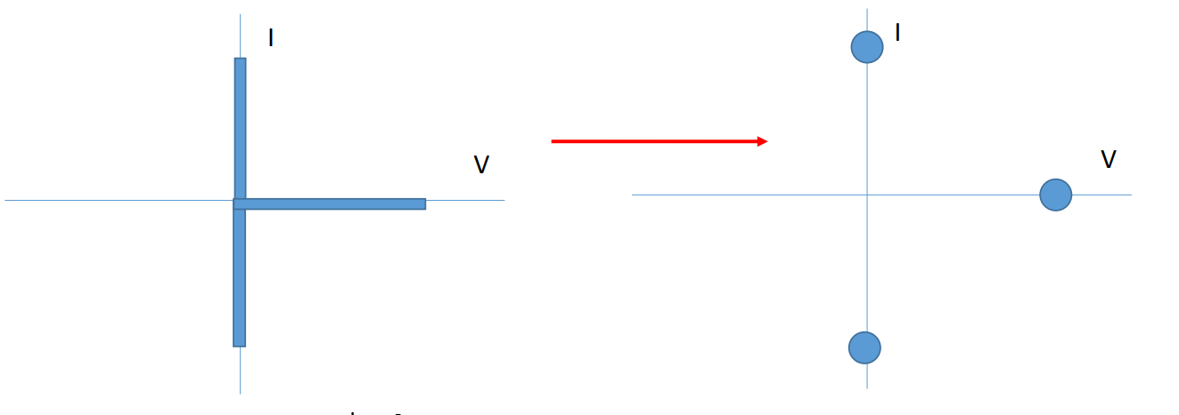 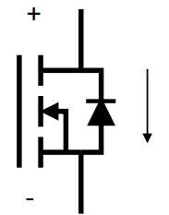

* 1. Specifications of the MOSFET:
     1. Device conducts when vGS>vTH. Else, it stops. In OFF state, a very small leakage current is produced, which can be ignored.
     2. In the ON state, the device is equivalent to a resistor, Von = Rds(on)*Ion and Pon = Rds(on)*Ion2.
     3. The switches take a finite time to switch ON and OFF after the gate pulses
        1. ton = td(on) + tr [td(on) = on delay time; tr = rise time]
        2. toff = td(off) +tf [td(off) = off delay time; tf = fall time]
     4. It has both switching and ON state loss, and requires a gate drive circuit.

# IGBT (Insulated Gate Bipolar Transistor)

* 1. Combination of MOSFET (low gate drive power requirement, high input impedance) and BJT (high current carrying capacity, low on state loss).
  2. Available up to 3.3 kV, 1500A, Switching frequency up to 20 kHz.
  3. Mainly used in low and medium power from several hundreds of kW and multi-MW level.

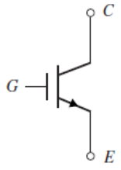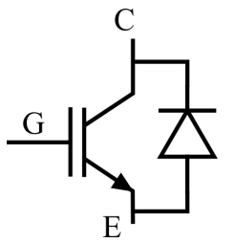

* 1. I-V characteristics very similar to MOSFET.

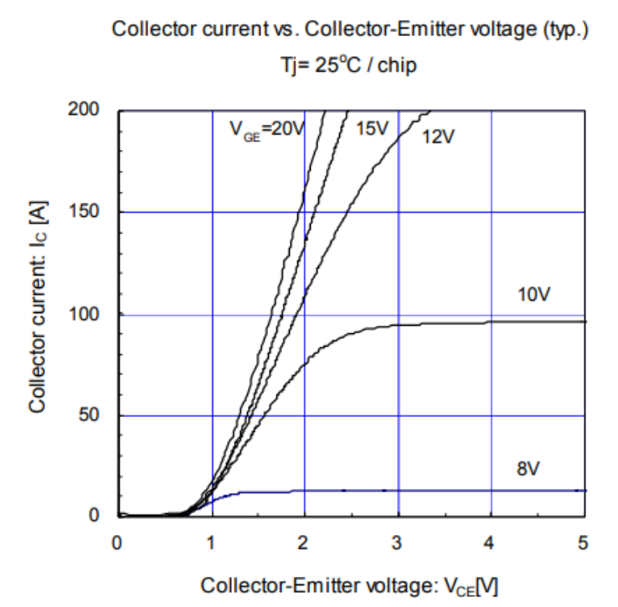

* 1. Quadrants of operation:

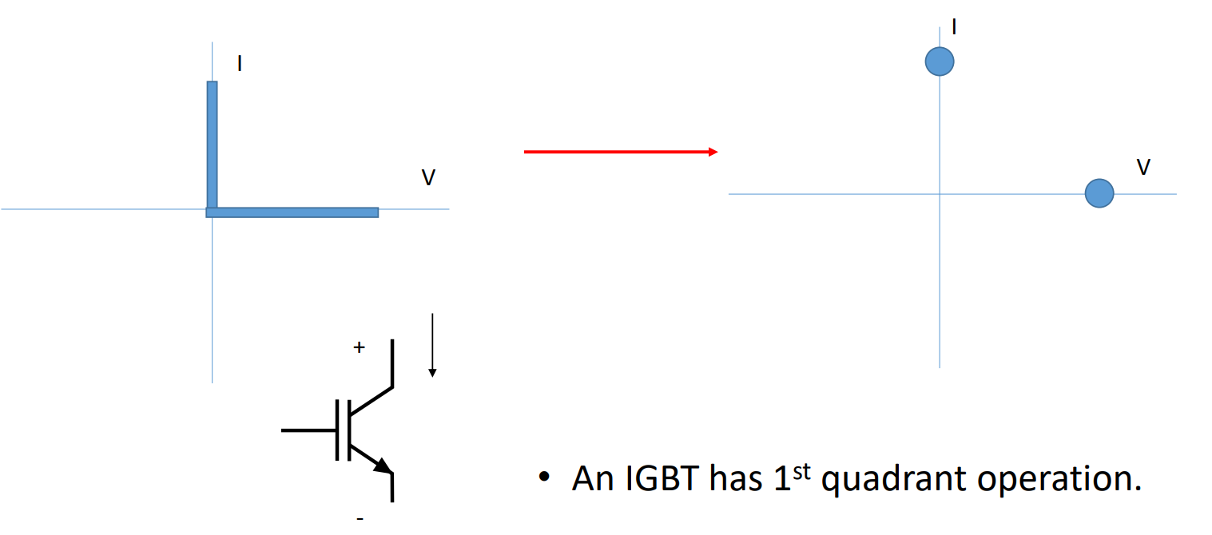

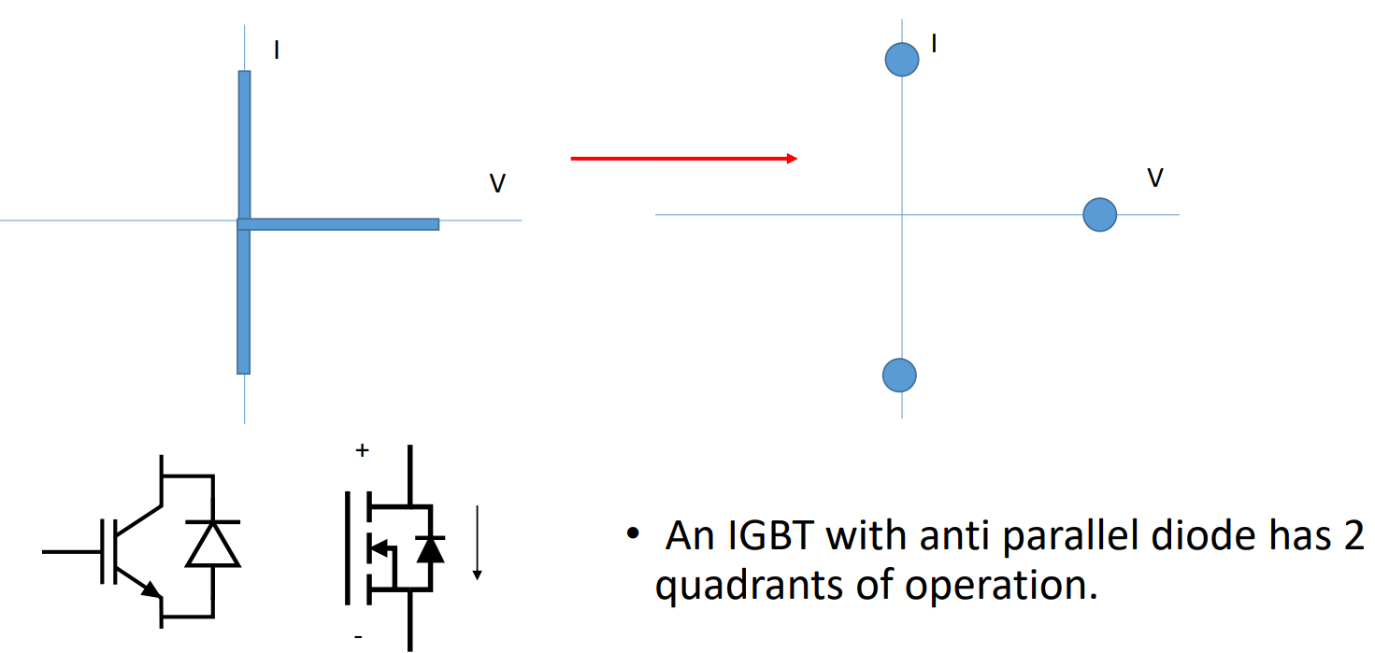

* 1. Specifications of IGBT:
     1. Device conducts when vGE>vTH. Else, it stops. In OFF state, negligible leakage current flows through.
     2. In ON state, voltage drop Vce(sat), power dissipated Pon= Vce(sat)*Ion.
     3. Switches take a finite time to switch ON and OFF after the gate pulses:
        1. ton = td(on) + tr; td(on) = on delay time; tr = rise time
        2. toff = td(off) +tf; td(off) = off delay time; tf = fall time
     4. Has both switching and on state loss, and requires a gate drive circuit.

# Thyristor (Silicon Controlled Rectifier)

* 1. 3-terminal, 4 semiconductor p-n junction device. The 3rd terminal (gate) is used for control purposes.
  2. Oldest of controlled power devices, application is limited nowadays to very high-power area e.g., HVDC transmission or low power like electronic breaker.
  3. Can be controlled to turn on, but can’t be controlled to turn off. Turns off when the current is zero.
  4. SCR can block voltages bidirectionally and carry the current unidirectionally.

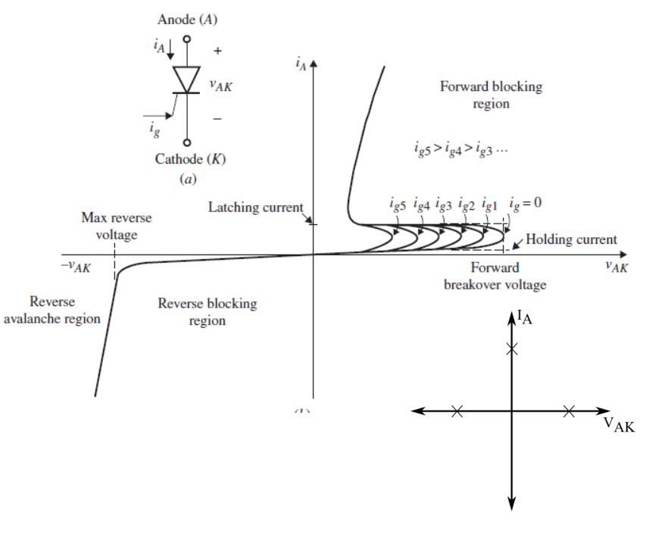

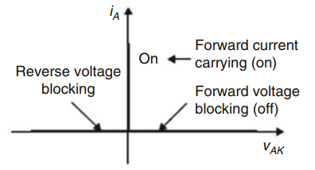

* 1. Has 2 quadrants of operation:

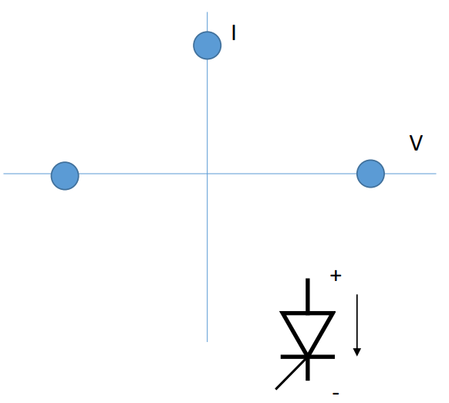

# GTO (Gate turn off thyristor)

* 1. Unlike thyristors, GTO can be turned off by applying a negative gate signal; IGCT (Integrated Gate commutation thyristor) also works on the same principle.

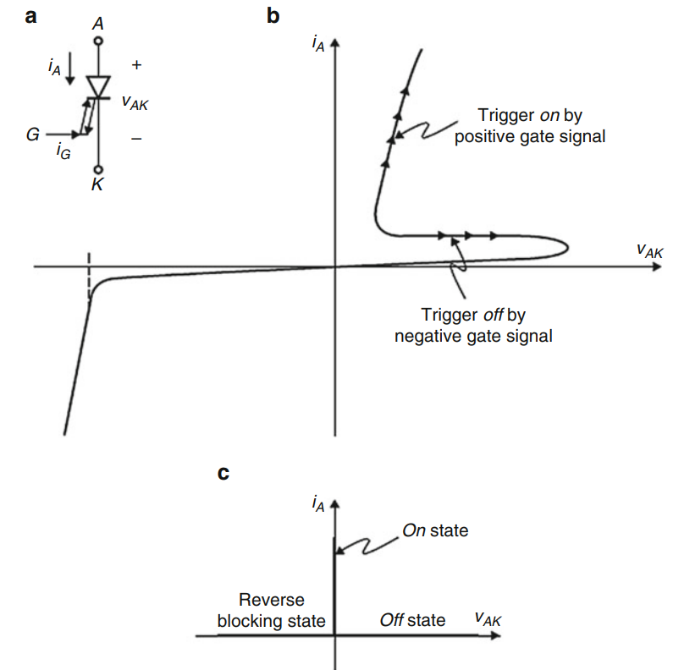

# The Triode AC Switch (TRIAC)

* 1. TRIAC is nothing but a pair of SCRs connected in reverse parallel.

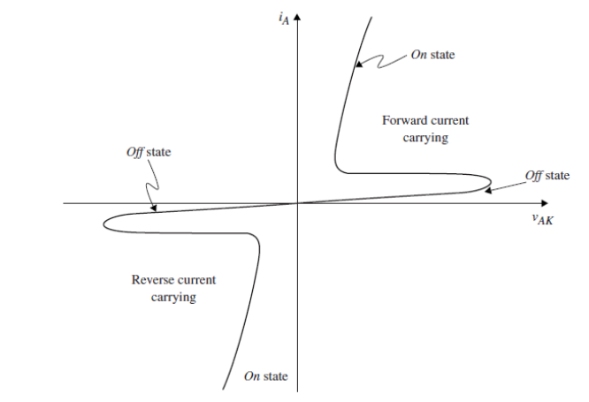

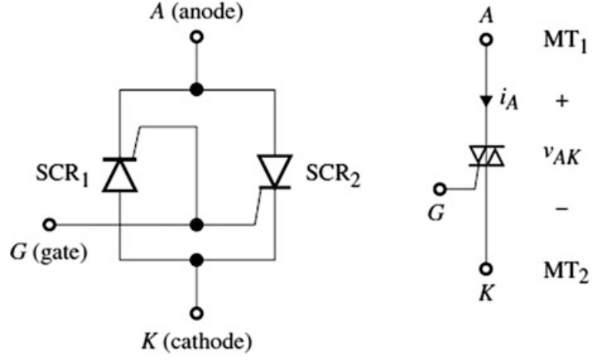

* 1. Has 4 quadrants of operation: can block voltages in both directions and allow current in both directions.

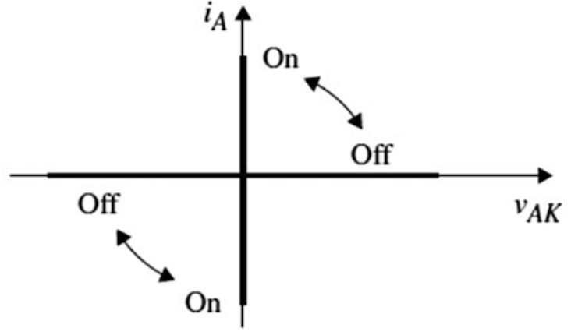

# Advantages and challenges with SiC devices

Silicon Carbide (SiC) has better electrical properties than Silicon. Compared to Silicon, SiC has:

1. Higher critical breakdown field (about 10 times), which means the same voltage rating can be maintained while reducing the thickness of the device. With reduction in thickness, the on-state resistance is reduced. Thus, conduction losses are smaller.
2. A wider bandgap, leading to lower leakage current at relatively high temperatures. Thus, SiC can work at higher operating temperatures.
3. Higher electron saturation velocity (about 2 times), thus the device can turn on and turn off faster.
4. Higher thermal conductivity, which ensures lower temperature rise.

SiC devices have the following challenges associated:

1. Because SiC can switch faster, the di/dt is faster. This causes higher voltage overshoot and ringing across the device. This can cause higher switching losses and EMI issues.
2. Packaging is a challenging issue.

# Losses in power switches

* 1. Two main types of switch losses:
     1. Switching loss (while switching the switch between ON and OFF), because of the finite switching time.
     2. Conduction loss (while the switch is fully working in ON or OFF state).

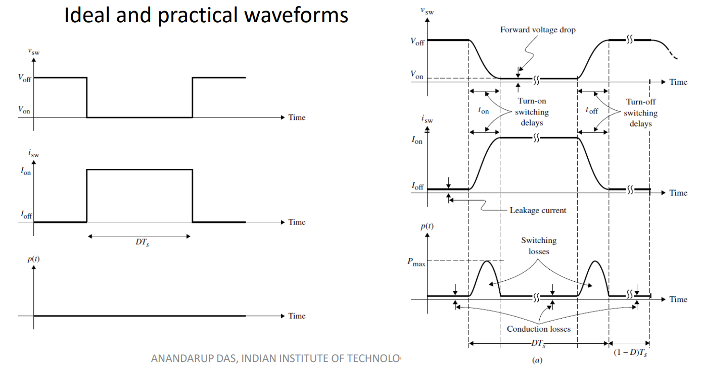

* 1. Every time the switch turns on or off, there is a pulse of energy dissipated. While the switch is fully turned on, there is a steady dissipation of energy. The total effect of these phenomena causes the temperature to rise inside the device.
  2. Thermal model for losses:- We use the following results:

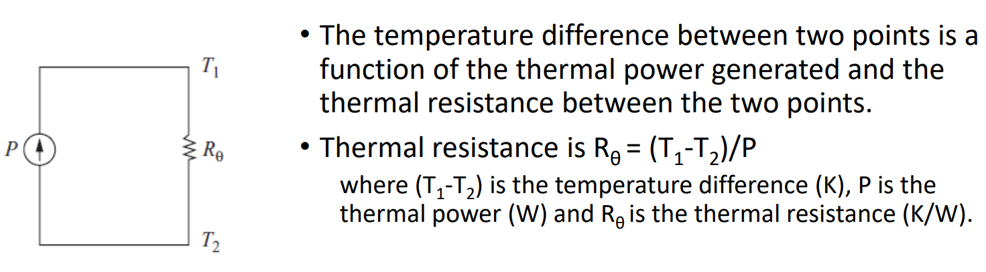

* 1. If T2 is the temperature of ambient and T1 is the temperature of the junction, then a heat sink will reduce Rθ between the junction and the ambient, and hence T1 will decrease. A heat sink with a fan will further reduce Rθ.

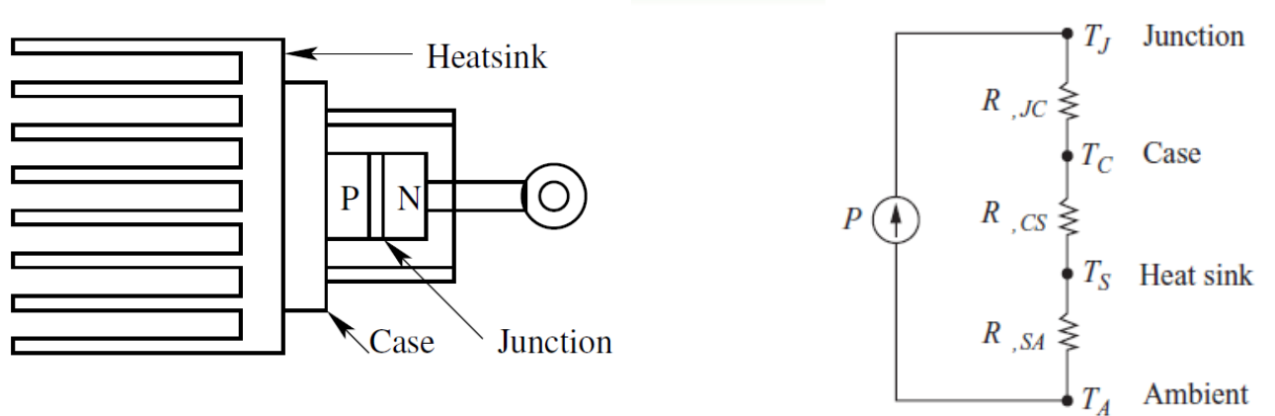

* 1. Thermal power flows from junction to case, then from case to heatsink, then from heat sink to ambient. This is modelled as three series resistances: RθJC, RθCS, RθSA. Semiconductor and heat sink manufacturers provide these values.

# DC-DC Converters: Basics

* 1. DC-DC converters are used for converting DC voltage of a certain magnitude to another magnitude.
     1. They are usually done by switching regulators rather than linear regulators to improve the efficiency.
     2. Basic switching regulators include buck, boost, and buck boost converters.
  2. Switching power converter:

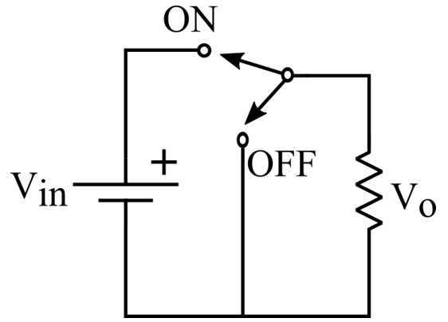

* 1. It has a 100% efficiency, however, the voltage pulsates and the desired voltage achieved is actually the average of the voltage across cycles, like the graph shown below.



* 1. To improve the output quality, an inductor is added to the circuit as shown:

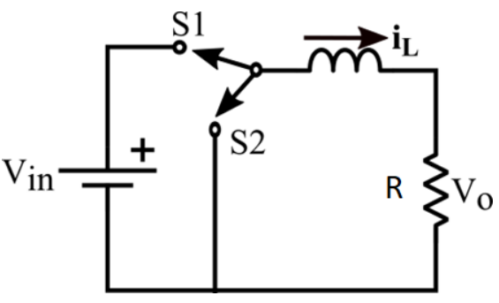

* 1. The output voltage becomes smoother, as the inductor retains current and charging-discharging cycle happens periodically, with an (L/R) time constant.

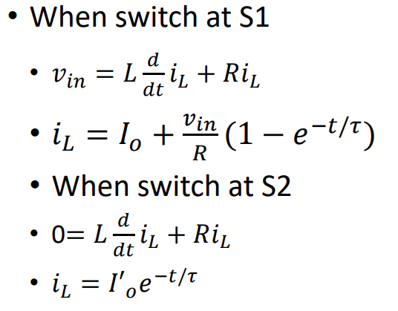

* 1. If time constant is much larger than the switching time period, the charging and discharging of the inductor happens very slow, and the current can be assumed as linear.

# Buck Converter

* 1. Now, the addition of inductor has made the change in the current smoother, but still, there is an output voltage ripple. This can be reduced by adding a capacitor in parallel, as shown, in the circuit.

A steady state approximation can be made in such a case that the V0 is constant, with very little ripple, as the time constant of the inductor is very large in comparison to the switching frequency.

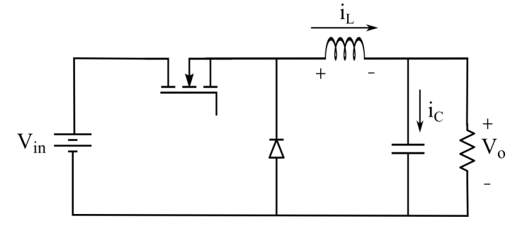

* 1. Current flowing through the inductor (v0 is assumed as constant and iL is assumed as linear, due to steady state approximation).

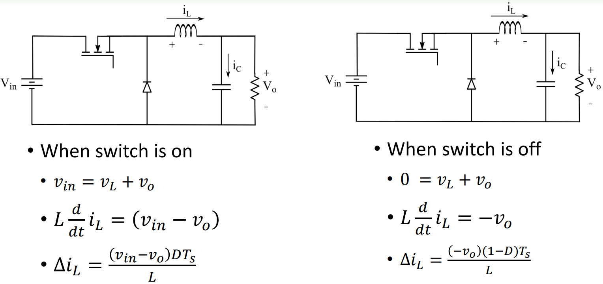

* 1. Some steady-state assumptions:
     1. When steady state is reached, then inductor current buildup over a time period (Ts) should be zero.
     2. In other words, at steady state, energy content in the inductor should remain constant in a time period Ts. Similarly, energy content in the capacitor should remain constant in Ts.
  2. Volt-second balance principle for inductor: The net current change through an inductor adds up to zero for a cycle.

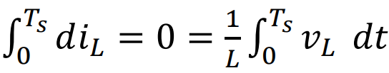

* 1. Ampere-second balance principle for capacitor: The net voltage change across a capacitor adds up to zero for a cycle.

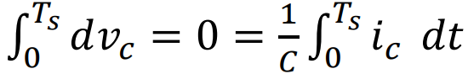

* 1. Input Output Voltage relation:

Using the facts that the ripple voltage is negligible, and the volt-second balance for the inductor, we get

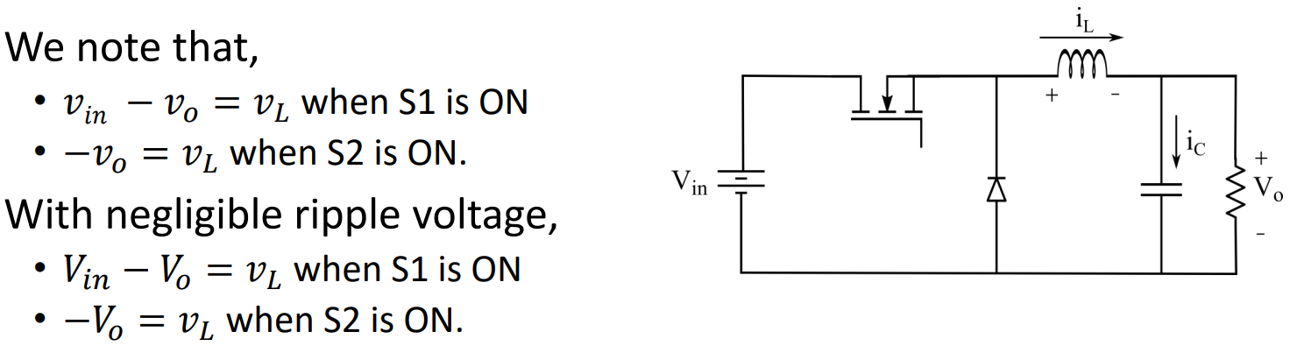

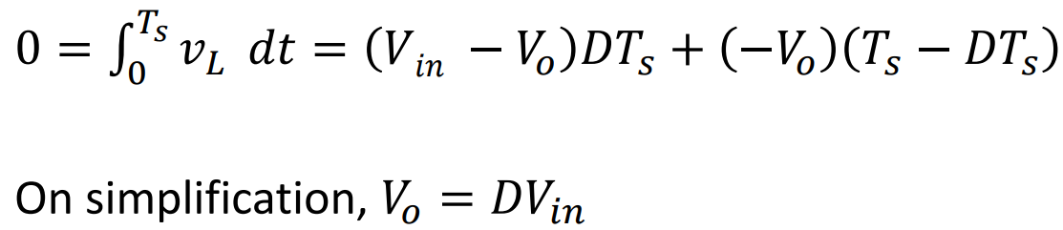

* 1. The energy conservation principle/first law of thermodynamics applied across the circuit gives rise to the following relation:

, therefore, 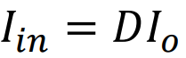

* 1. Waveforms for the Buck converter:

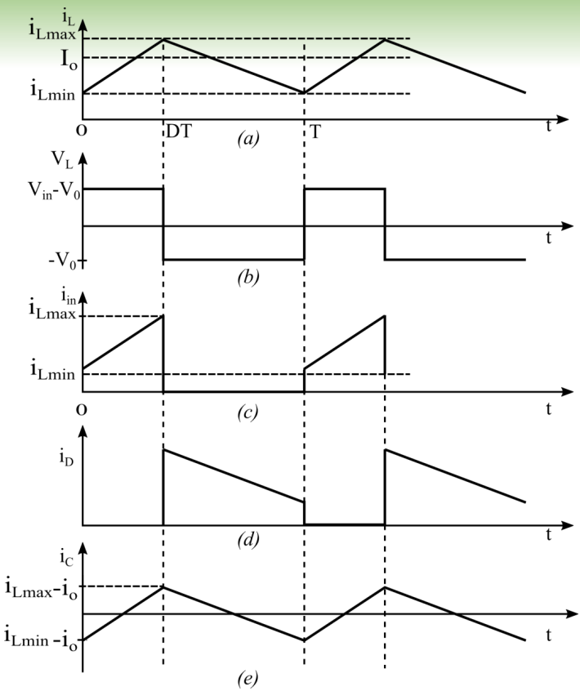

* 1. Some relationships:
     1. 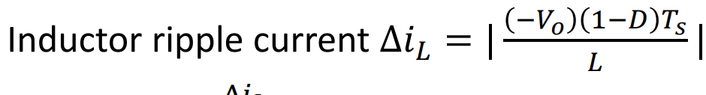
     2. 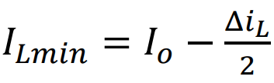
     3. 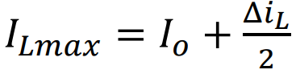
     4. Average value of inductor current = load current.
     5. Average current through capacitor=0. Average value of inductor voltage=0.
     6. Switching frequency of switch and diode are same
  2. Design of L:
     1. Inductor ripple current taken as 10% of inductor current.
     2. 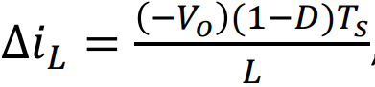, therefore, 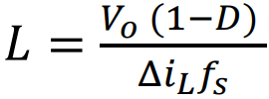
  3. Design of C:
     1. The capacitance is calculated using charge balance (or Ampere second) method. We assume that the DC flows through the load, while the ripple flows through the capacitor.
     2. Since , and the capacitor current is triangular, so the capacitor ripple voltage is parabolic

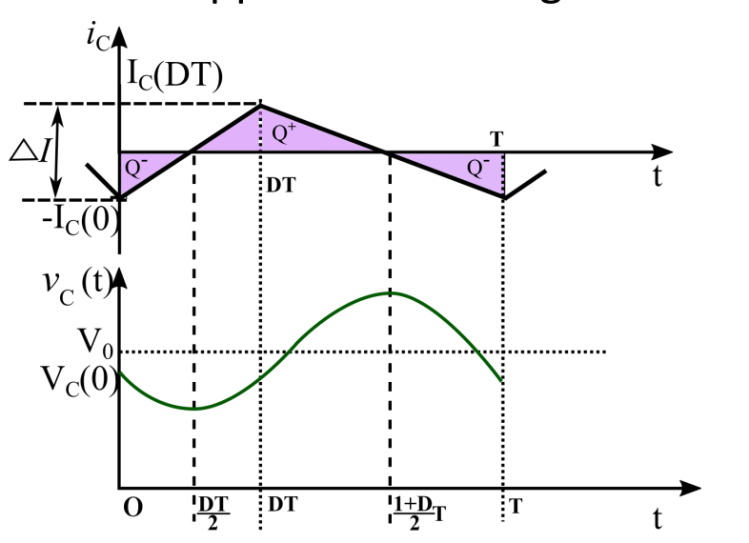

* + 1. The capacitor voltage ripple is usually taken 1-2% of the capacitor voltage.
    2. 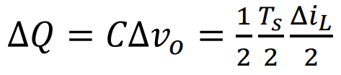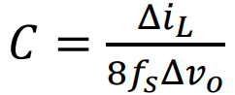
    3. 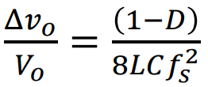
  1. Observation for buck converter:
     1. The output voltage is always less than input voltage. The voltage gain of the converter is independent of switching frequency.
     2. The output voltage ripple is independent of the load resistance.
     3. The input current is discontinuous and pulsating. If the source cannot supply such a current, then we should provide an input filter.
     4. The ideal efficiency is 1, however practical efficiency is less than 1 (e.g., 0.85 to 0.95).
  2. Non idealities in buck converter:
     1. There are several non idealities in Buck converter. Inductor resistance, diode and switch drops are some of them.
     2. In case of inductor resistance:

Gain = Vout/Vin = 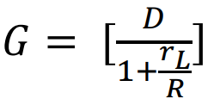

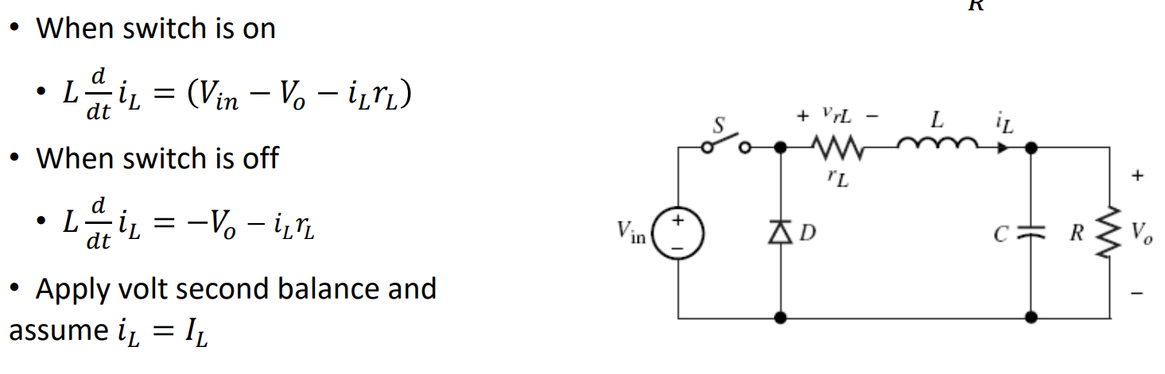

* + 1. Actual efficiency of buck converter:

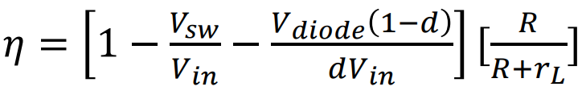

# Boost Converter

* 1. The position of the inductor can be changed from output to input side.
  2. Hence, compared to buck converter, the position of switch, diode and inductor has changed.
  3. We now get the boost converter. The output voltage is more than the input.

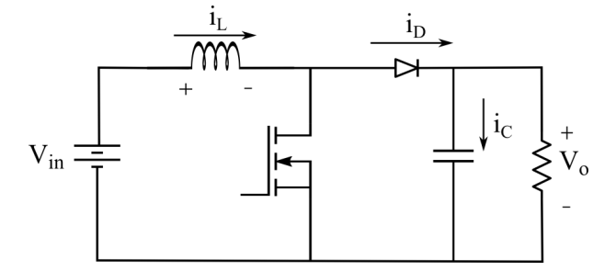

* 1. Circuit analysis:

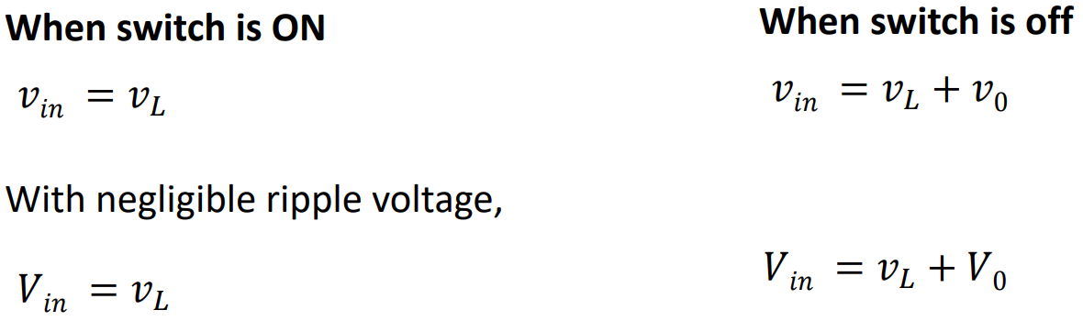

* 1. From volt-second balance on inductor:

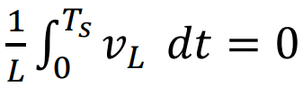



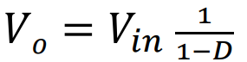

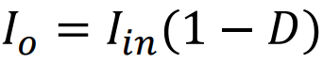

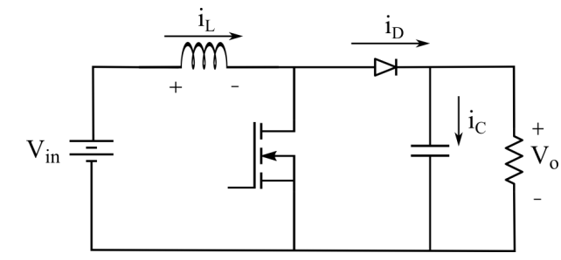

* 1. Waveforms:

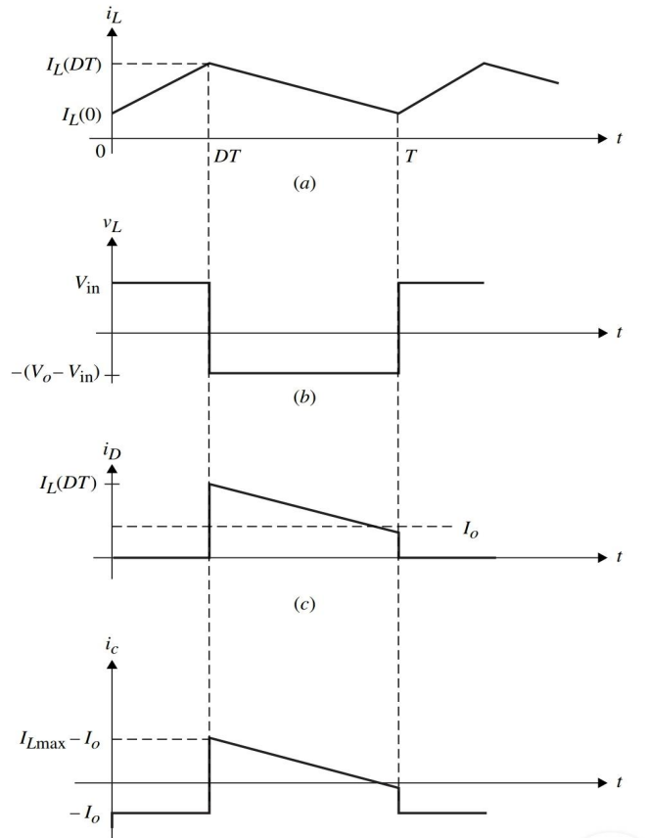

* 1. Inductor current:

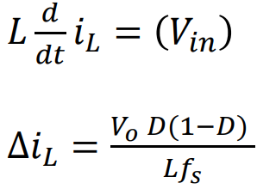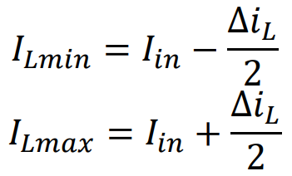

* 1. Boost capacitor voltage:
     1. When switch is on, capacitor will supply constant current to load. So, the capacitor discharges almost linearly.
     2. When switch is off, capacitor will charge from the inductor current.

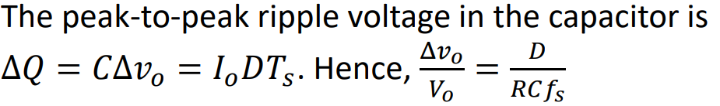

* 1. Practical Voltage gain in boost converter:
     1. Ideally, voltage gain should approach infinity as D approaches 1.
     2. However, the inductor resistance prevents it from happening. Instead, the expression and graph of gain is given below:

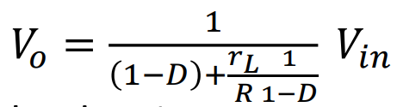

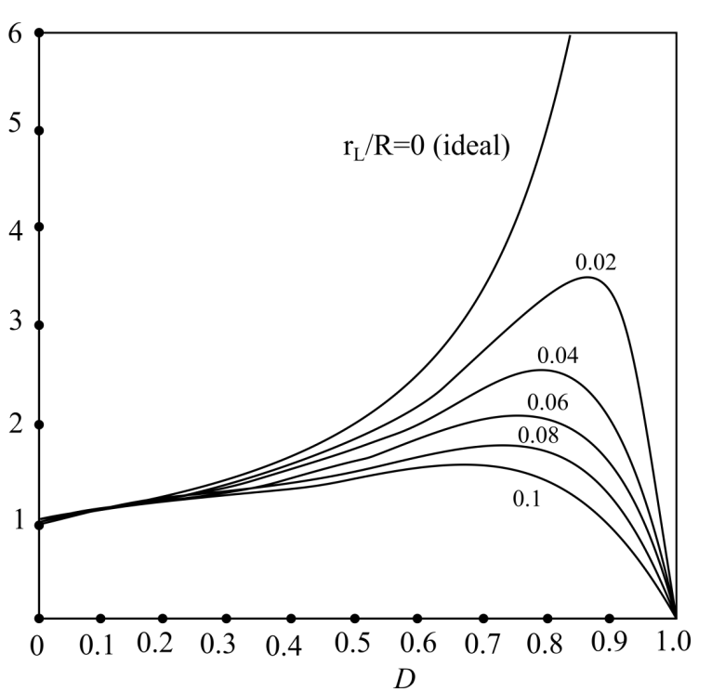

# Buck-Boost Converter

* 1. Output voltage can be more, equal to or less than the input voltage, but in opposite direction.

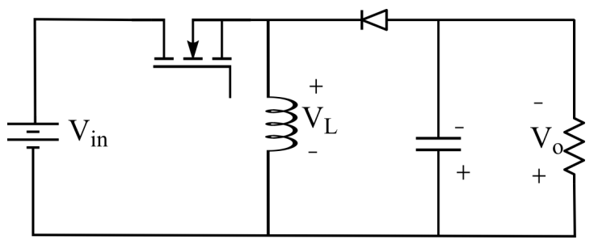

* 1. Operation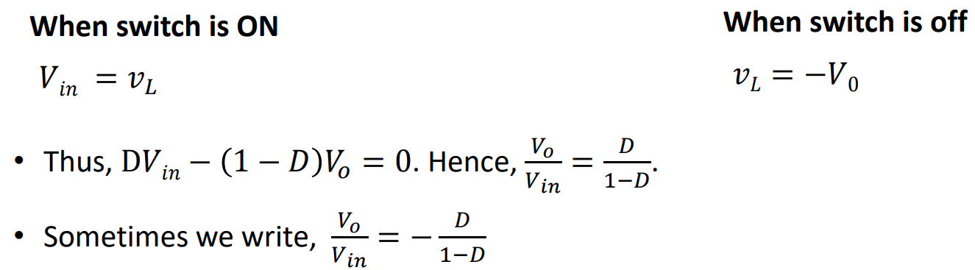
  2. Waveforms:

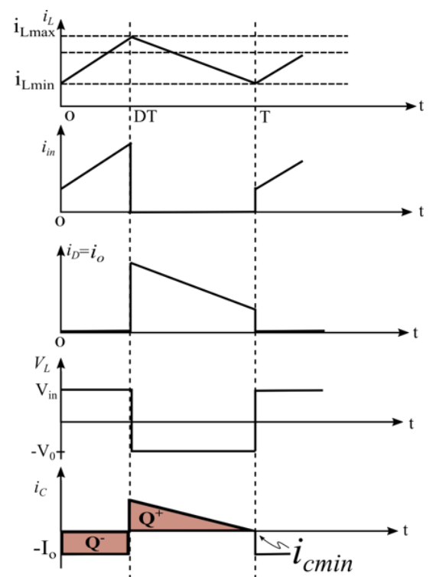

# Discontinuous Conduction Mode

* 1. When the load current reduces, the buck (or other) converters starts to move into the DCM mode.
  2. If we keep the output voltage constant, the inductor current ripple is constant irrespective of the load current.

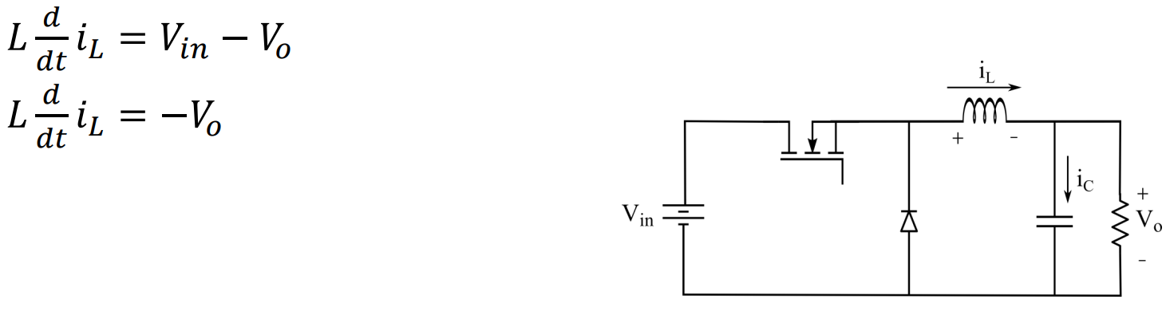

* 1. The average inductor current is same as load current. As load resistance increases, I0 falls but Δ𝑖𝐿 remains constant. The inductor current moves into DCM.
  2. At the boundary of CCM and DCM, the minimum value of I0 for CCM I0min:

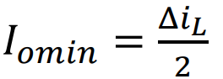

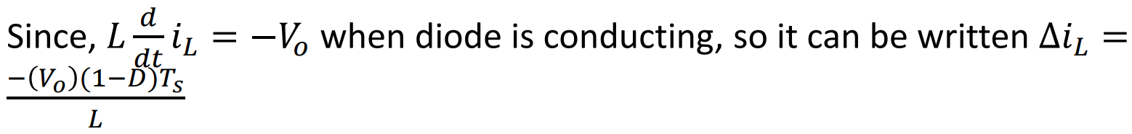

* 1. Absolute value of ripple current:

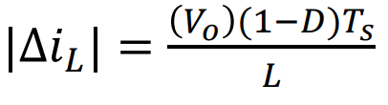

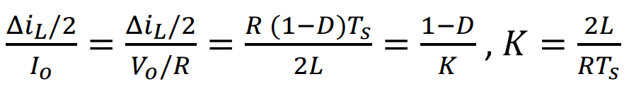

* 1. K is a factor which controls when the converter will move into DCM. If K<(1-D), the converter moves into DCM.
  2. DCM through critical inductance:

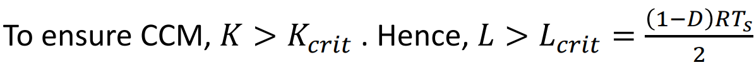

* 1. Voltage gain during DCM:

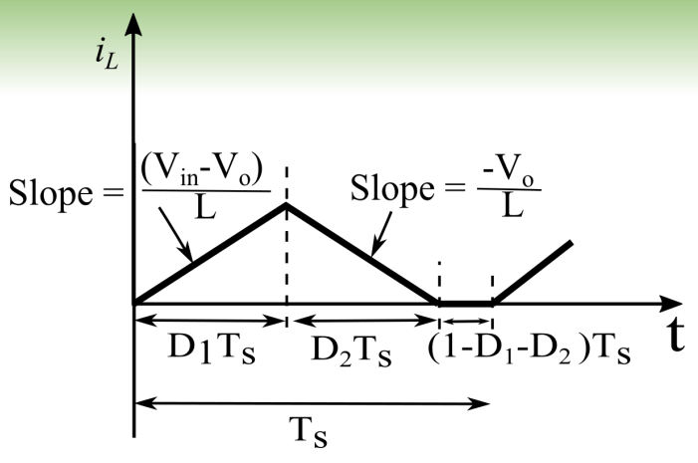

* 1. Applying the volt-second balance:

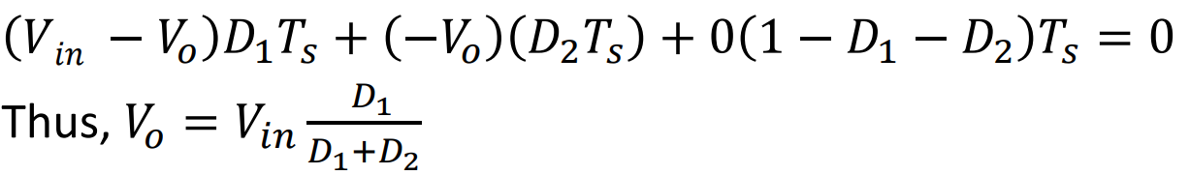

* 1. D1 and D2 can be calculated using:

